**CSIS 2260 - Lab #1**

20

***Installation of Windows 10 in VirtualBox***

Due date: 20:59 Jan 15, 2021 (Pacific Time)

**Name: Stephen Joy Student No.: 300329148 Section: CSIS 2260 - 012**

**Insert the required screenshots in the Word file. Do not submit the screenshots separately.**

**Use a different font color for your answers.**

**Introduction:** This lab provides an introduction to virtual machine (VM). You will learn how to create a Windows 10 VM (which is referred to as ***guest system***) on top of your own Windows 10 system (***host system***) using VirtualBox.

**Objectives:**

1. To install VirtualBox on Windows 10 environment.
2. To set up a Windows 10 virtual machine.
3. To get familiar with Windows 10.

**Equipment Required:**

1. A Windows 10 64-bit Desktop/Laptop with at least 8 GB and 100 GB free disk space (Mac OS may work but you need to troubleshoot by yourself), good and stable network connection, and one USB Flash Drive in good condition.
2. You are required to download **VirtualBox 6.1.16** BEFORE the lab session from <https://www.virtualbox.org/wiki/Downloads> (Click *Windows hosts* to download).
3. You are required to download the Windows 10 Education ISO disk image file and obtain your own Windows 10 product key BEFORE the lab session. To obtain Windows 10 Education, go to <https://azureforeducation.microsoft.com/devtools> and sign in using your Douglas College student account. Under Learning resources > Software, choose ***Windows 10 Education, version 20H2 - DVD*** (NOT Windows 10 Education N) and click *Generate URL* to obtain the download URL. Open the URL in a web browser to download the Windows 10 .iso file. Click *View* *Key* to get the Product Key which will be used for Windows 10 VM installation later.
4. **Installation of VirtualBox [_____/4]**
5. Make sure the C: partition has enough free disk space on your computer.
6. Install VirtualBox on your computer and take the default settings of installation.
7. Start the VirtualBox application, and it should look like the following.

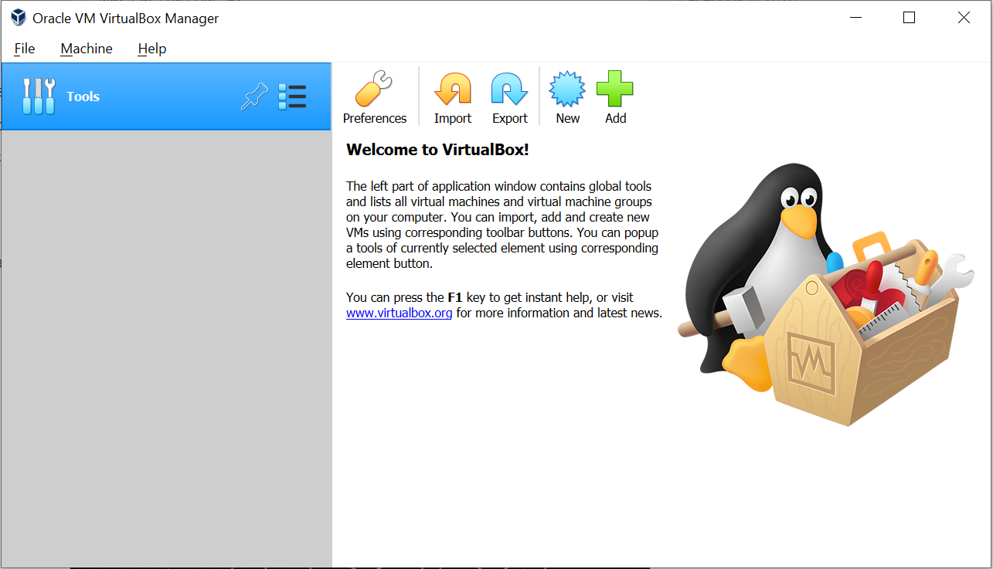

1. **Installation of Windows 10 Virtual Machine [_____/6]**
2. Click ***New*** to create a new virtual machine for Windows 10 (64-bit).
   1. Use ***Windows 10*** as the name of the virtual machine.
   2. Take the default settings for other options when creating of the VM.
3. Install Windows 10 on your virtual machine
   1. Choose the ***Windows 10*** virtual machine just created and click ***Start*** to power on it.
   2. When prompt to select start-up disk, click the folder icon on the right. Click ***Add*** to select the Windows 10 .iso file you have downloaded and click ***Choose***. Click ***Start*** to begin system installation.
   3. If prompted, use your own product key to complete the installation.
   4. Choose ***Custom: Install Windows only (advanced)*** to install a new copy of Windows 10.
   5. Delete all partitions on the hard drive if needed to make the whole hard drive as a single partition C:\. (Normally you will only see ***Drive 0 Unallocated Space*** and just select it)
   6. The system will reboot automatically when installation finishes.
   7. Use default settings for language and keyboard layout and skip the second keyboard layout.
   8. Select ***Domain join instead*** at the bottom when asked account to sign in. Type your first name when asked *Who’s going to use this PC* and use **csis** as the password. Set up the security questions by yourself.
   9. Decline using Cortana. Set ***NO*** for other options asked during the rest of the installation process.

Note: If product key was not asked during system installation, change the Windows 10 license key as follows: Go to ***Settings*** > ***Update******&******Security*** > ***Activation*** > ***Change******product******key***, enter your own Windows 10 product key and click *Upgrade now*.

1. **System Information and Basic System Settings [_____/10]**

1. Click the ***Start*** button at the lower left-hand corner and click ***Windows******System.***Right click ***This PC*** and select ***Properties***. Give the system information provided.

Processor: **Intel(R) Core(TM) i5-10300H CPU @ 2.50GHz**

Installed memory (RAM): **2.00 GB.**

System type: **64-bit operating system, x64-based processor**

Take a screenshot of the ***Properties*** window and insert the screenshot below.

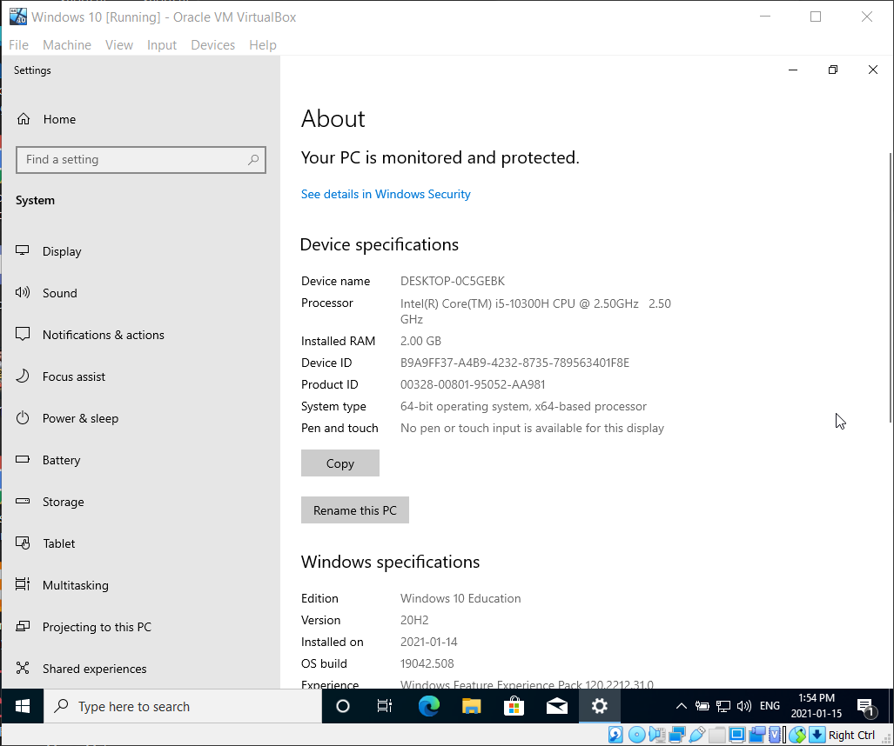

2. Click the ***Start*** button at the lower left-hand corner and select ***Settings***. Give FOUR of the main items that you can choose to set from the pop-up window.

* **System**
* **Devices**
* **Network & Internet**
* **Personalization**

3. Select ***System*** settings.

a) What are the resolutions that are available for your display?

* **1600 x 1200**
* **1280 x 1024**
* **1152 x 864**
* **1024 x 768**
* **800 x 600**

Adjust your display to the highest possible resolution and keep changes.

b) Select ***Storage*** and determine

The total storage space on your C: drive - **49.4 GB**

The amount of used space on C: drive – **18.7 GB**

4. Select ***Settings*** > ***Device***.

a) List the ***Printers & scanners*** available on your system.

* **Fax**
* **Microsoft Print to PDF**
* **Microsoft XPS Document Writer**
* **OneNote**

b) What are the settings provided under ***Typing > Spelling***?

* **Autocorrect misspelled words**
* **Highlight misspelled words**

c) Select ***AutoPlay***. Give two options available for ***Removable drive***.

* **Take no action**
* **Ask me every time**

5. Select ***Settings*** > ***Update & Security***.

a) List the functions provided under ***Recovery***.

* **Reset this PC**
* **Advanced startup**
* **More recovery options**
* **Fix problems without resetting your PC**
* **Help from the web**

6. Select ***Settings*** > ***Apps***.

a) Give any four ***Apps*** that are listed.

* **3D Viewer**
* **Alarms & Clock**
* **App Installer**
* **Calculator**

b) Select ***Default apps.*** What is the default web browser on your system? **Microsoft Edge**

1. **Shutdown the Virtual Machine**
2. Shut down the Windows 10 VM.
3. Close Oracle VM VirtualBox Manager.

**Submission**

1. Save your lab file as YourFirstname_yourID_Lab1.docx (example: Michael_1234_Lab1.docx)
2. Submit the WORD file through Blackboard before the due (**do not send labs by email please. Any lab submitted by email will be ignored**).
3. You may submit your lab multiple times, but only the LAST submission before the due will be graded.